OpenQuote 0.1 User Guide
Version: 0.1
Author: Matthew Tomlinson

Table of Contents
Introduction 3
Getting Started 4
Developer Portal 4
Developer Login 4
Developer Home 4
Creating a New Product 5
Product Manager Portal 5
Alfresco Content Management System Login 5
CMS Product Spaces 6
Product Templates 7
Creating New CMS Spaces 8
Creating a Product Using a Template 9
Viewing a Product 11
Registering a Product 12
Testing a Product 13
Editing a Product 15
Product Space 15
Adding a Quotation Question 16

Introduction
Welcome to the OpenQuote user guide. This document is designed to help you learn how to use the OpenQuote system and understand all its various aspects of operation.
OpenQuote is designed to allow insurance companies, agents and brokers to quickly and effectively create and edit insurance products, including risk assessment and rating rules. The system is design to enable this without the need for large amounts of IT intervention. OpenQuote delivers these products to market via the internet (or internally to a company via an intranet).
At present OpenQuote does not offer any policy administration functionality, it is designed simply to get the business to market as quickly as possible, thus enabling the business to remain competitive in any line of insurance.
OpenQuote is a server side system, this means it does not run locally on your PC, the system runs on a server and you access it using a web browser (Microsoft's Internet Explorer for example). This allows access from anywhere, from any PC, without the need to install or update the software on individual PC's.
OpenQuote is distributed under the The GNU General Public License (GPL), an open source licence. Open source software is free to use, although commercial support and licensing is available from Applied Industrial Logic (http://www.ail-ltd.com/) if required. For more details regarding open source and the OpenQuote licence please visit http://openquote.opensourceinsurance.org/opensource.php.
This user guide is written in the form of a tutorial, the functionality provide by OpenQuote will be described in different sections, but if followed from start to end will show an insurance product being created in full.

Getting Started

Developer Portal
To start, go to the developer area on the system, using a web browser go to:
http://<server name>:8080/portal/portal/developer
* Replace <server name> with the name of the pc you installed OpenQuote on. If you installed it on your desktop PC, replace <server name> with localhost.
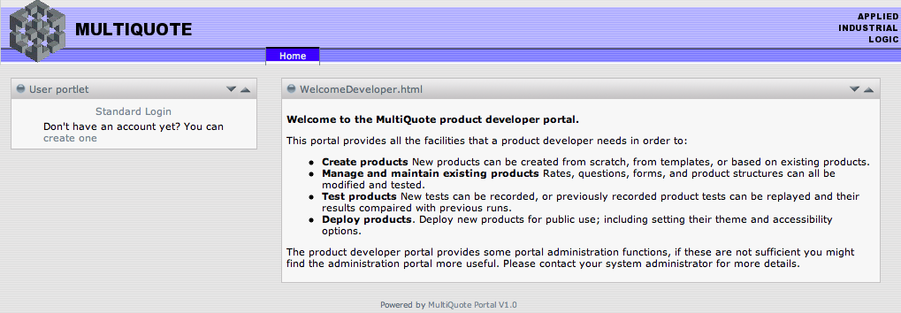

Developer Login
At this point we can use the default user name and password for the development of an insurance product, however if this installation is being used for anything more than training, new users and passwords should be set up and the default user removed.
Select “Standard Login”, enter a user name and password and click the “Login” button:
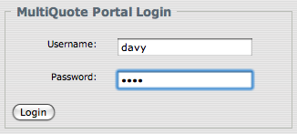
* The default OpenQuote development user name is “davy” and the password is also “davy”.

Developer Home
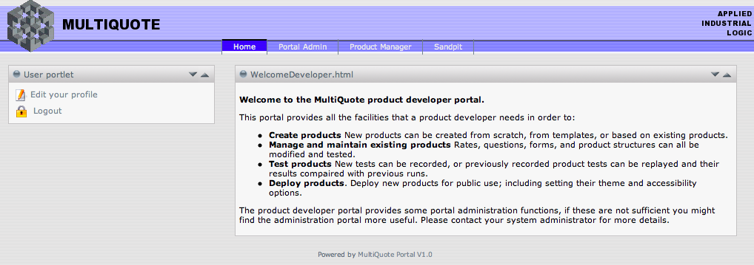

Creating a New Product

Product Manager Portal
From the Developer Home page select the Product Manager menu option, this will take you to the Product Manager page:
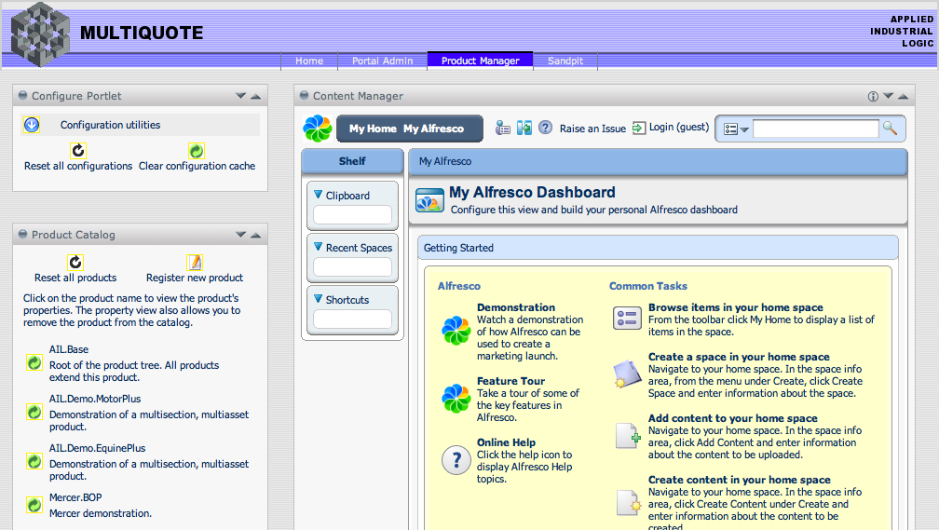
This page lists registered product, but before they can be edited you need to login to the Alfresco Content Management System (CMS).
- In future versions of OpenQuote this additional login will not be required as portal and CMS user profiles will be unified.

Alfresco Content Management System Login
* Before you can log into the CMS, you must be logged in as a Developer.
Select Login at the top of the Content Manager Portal, enter a user name and password and click the “Login” button:
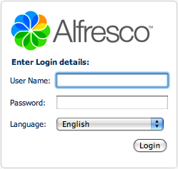
* The default OpenQuote CMS user name is “admin” and the password is also “admin”.

CMS Product Spaces
Once logged into the CMS, go to the Company Home area by clicking on the “Company Home” menu item at the top of the Content Manager Portal. From here you have access to everything needed to create and maintain insurance products.
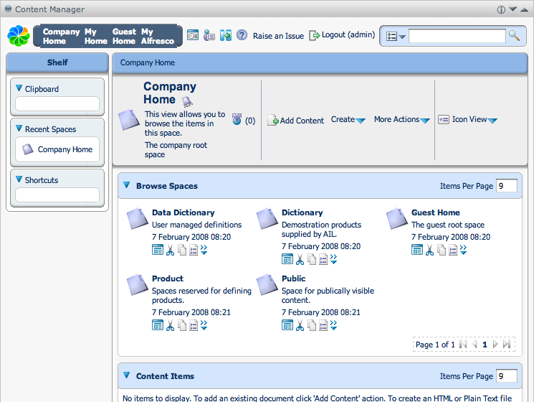

Product Templates
In the Content Manager, use the Browse Spaces area to navigate into the “Dictionary” space and then into the “Space Templates” space, it is in here that the product templates reside:
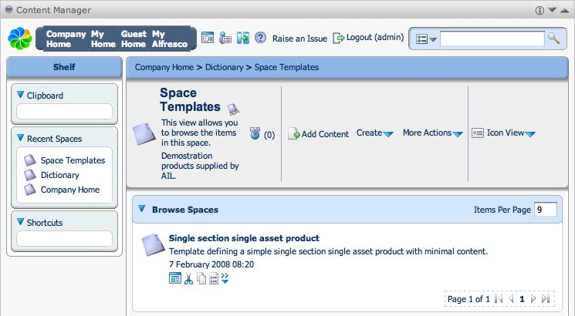
Product templates can be used as a starting point for creating basic insurance product definitions, these can then be edited to form products for whatever line of business required.
Currently only one template exists, this is a simple single section product template, however more templates will be added in the future to aide the creation of many different types of product.
Product templates can be created and edited in exactly the same way as products. The only difference is that they do not have to be a complete working product.
Navigating into the “Single section single asset product” space allows you to see the contents of the template:
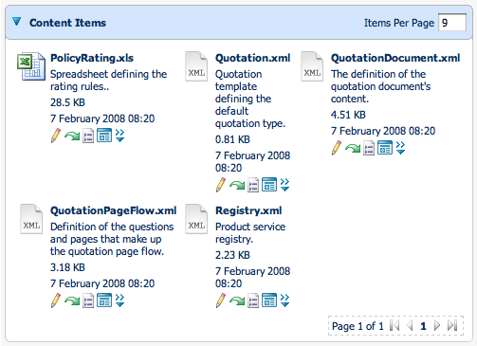

Creating New CMS Spaces
Before you start creating new products, it may be useful to create a new space to put these products in although you can also use an existing space. In the Content Manager, return to “Company Home” and use the Browse Spaces area to navigate into the “Product” space.
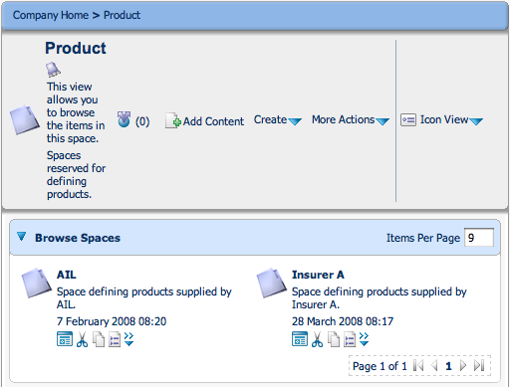
Click on “Create” and select the “Create Space” menu item. Now enter a Name for your space (do not use spaces or special characters), the other fields are optional. Once complete click “Create Space”.
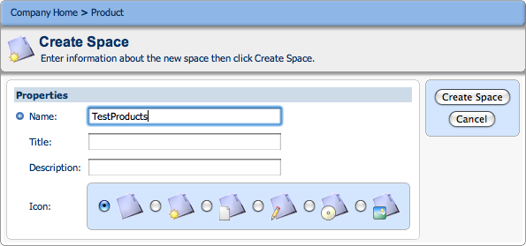
The new space will now appear in the Content Manager's Browse Spaces area. When you enter the new space it will be empty.
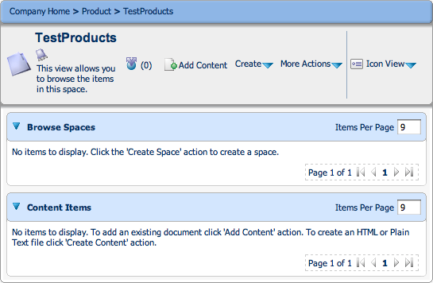

Creating a Product Using a Template
Before creating a product, you must first navigate the the CMS space you want the product to be created in. Once you have done this click on “Create” and select the “Advanced Space Wizard” menu item. Now enter a Name for your space, the other fields are optional. Once complete click “Create Space”.
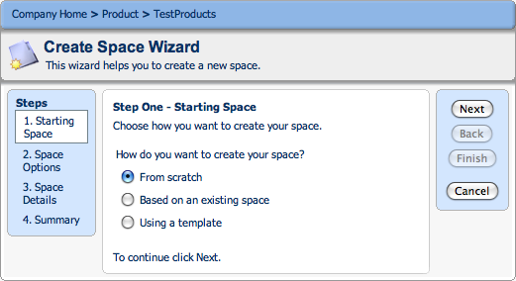
In the wizard select “Based on an existing space” (in future versions of OpenQuote you will select “Using a template”) and click “Next”.
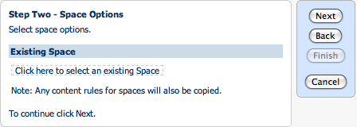
In step two select “Click here to select an existing Space” and navigate to the template you wish to use. To use the existing single section single asset product template navigate with the following steps:
“Go up” > “Dictionary” > “Space Templates” (clicking on the text)
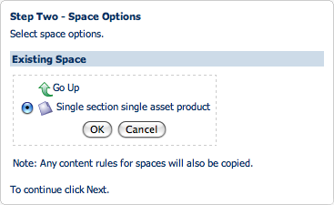
Select the template and click “OK”.

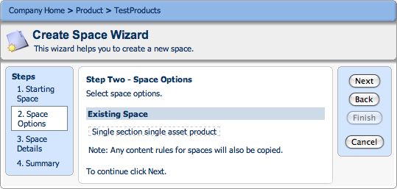
Once the required template is selected click “Next” to proceed to the next step of the wizard.
From the next step you can enter a product name (do not use spaces or special characters), title, description and select an icon, only the name is mandatory and once the details are completed you can click “Finish” to create the product.
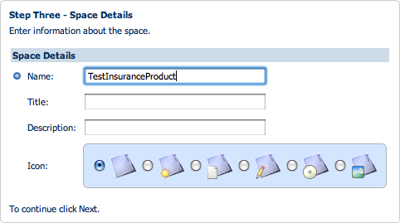
If you choose to click “Next” instead of “Finish” a final summary page is displayed.
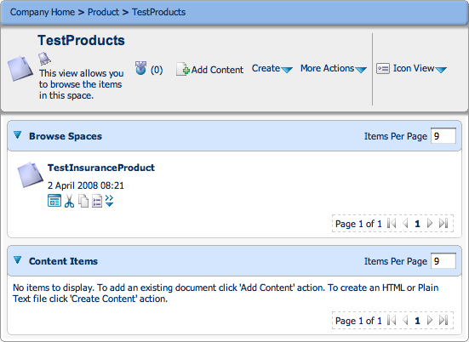

Viewing a Product
Select the product you want to edit in the Browse Spaces area of the Content Manager. Click the product to see it's contents. If the product is new and was created using the single section single asset template, the CMS space will look like this:
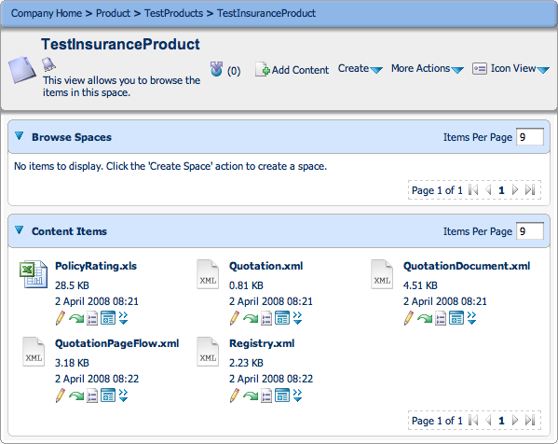

Registering a Product
Before a product can be used or tested it must be registered. To do this click “Register new product” in the Product Catalogue portal.
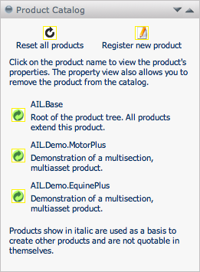
Enter the location of the Product and click “Save”. The location consists of the folder names containing the product and the Product space name, separated by dots:
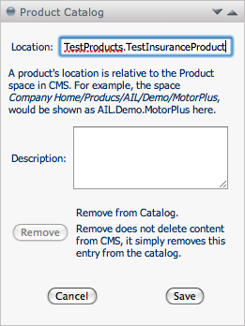
Once registered, click “Reset all products”. The product is now ready for use,

Testing a Product
Once a product is registered it can be run in the Sandpit, this is test area for products. To start testing select the “Sandpit” menu item.
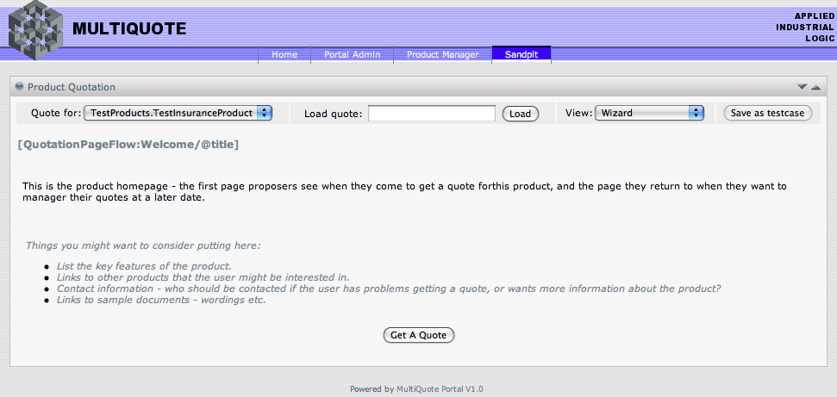
The sandpit allows you to walk through the quotation screens for any registered product.

By default all products use a generic proposer contact details screen, this is the first screen in the information capture process for a quote (screen order can be altered later):
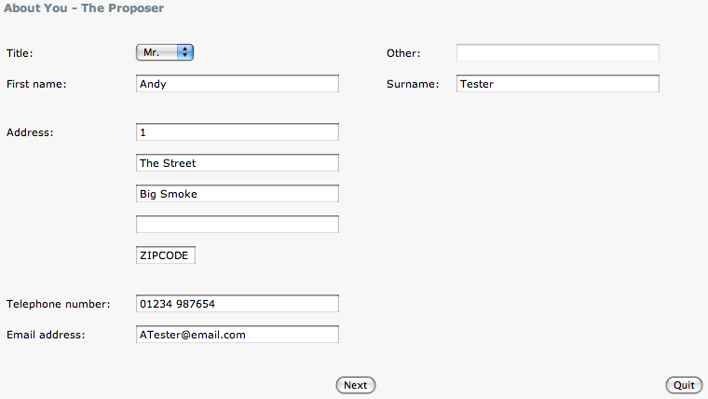
Next (in the default configuration for screen order) are the risk information screens. New products based upon the Single Section Single Asset product template do have some basic data entry and risk assessment rules set-up for example purposes:
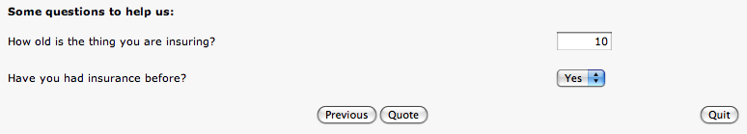
Assuming the risk assessment rules are happy with the previously entered details you will get a quoted premium:
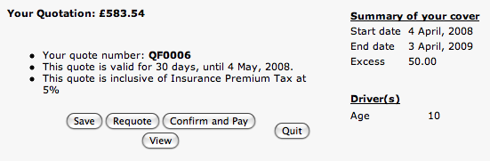
If the risk assessment rules are not happy the risk will be referred or declined. Clicking “Requote” on any of these screens allows you to go back an change the risk details.

Once a quote has been given, the proposer has a number of options:
- The quote can be saved allowing the proposer to return at a later date.
- The quote can be accepted and payment details entered.
- The risk details can be changed (Requote).
- The quote can be viewed (the current screen).
- The proposer can quit – losing the quote (the quote is saved, but the proposer will not be able to access it).

Editing a Product

Product Space
Select the product space that you want to edit.
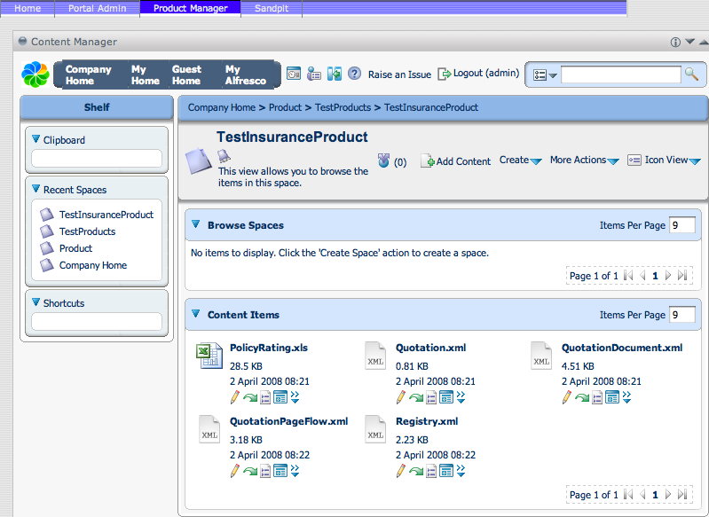

Adding a Quotation Question
There are a number of steps involved in adding a question to you quotation process. Currently the process involves editing xml files manually, future releases of OpenQuote will introduce a more user friendly approach using configuration screens and wizards.

Step 1 – Edit Quotation.xml (policy/quotation structure)
The Quotation.xml file specifies the structure of thev policy quote, detailing sections, assets, attributes etc..
In the product space, click the pencil icon beneath the Quotation.xml file, this opens the file ready for editing:
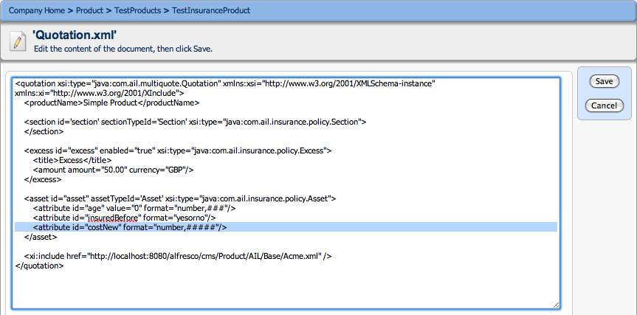
In this example a new “Cost when new” information field is being added, this is done by adding the line:
<attribute id="costNew" format="number,#####"/>
The field is given an identifier of “costNew” and a 5 digit numeric format.

Once the new field details have been entered, click on “Save”.

Step 2 – Edit QuotationPageFlow.xml (web page order and layout)
The QuotationPageFlow.xml file specifies where and how questions are asked and information is displayed during the quotation process.
In the product space, click the pencil icon () beneath the QuotationPageFlow.xml file:
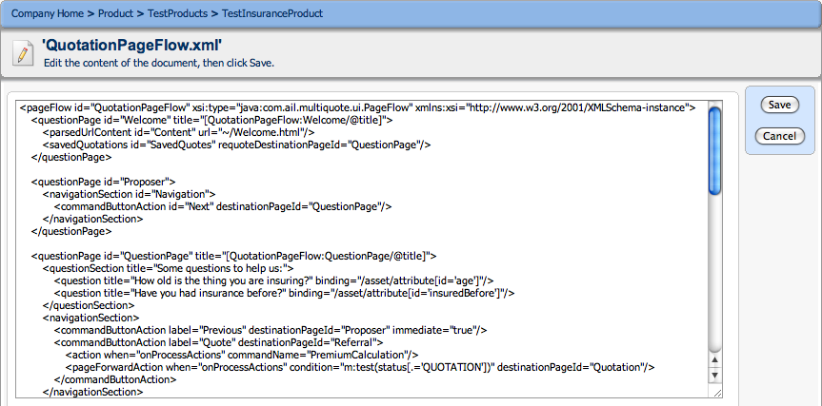
Following on with the “Cost when new” information field that was added to the Quotation.xml file, we now need to add the details describing where the question will be asked to populated this field. Add the highlighted line to the file:
<questionPage id="QuestionPage" title="[QuotationPageFlow:QuestionPage/@title]">
<questionSection title="Some questions to help us:">
<question title="How old is the thing you are insuring?" binding="/asset/attribute[id='age']"/>
<question title="Have you had insurance before?" binding="/asset/attribute[id='insuredBefore']"/>
<question title="What was the cost when new?" binding="/asset/attribute[id='costNew']"/>
</questionSection>
<navigationSection>
<commandButtonAction label="Previous" destinationPageId="Proposer" immediate="true"/>
<commandButtonAction label="Quote" destinationPageId="Referral">
<action when="onProcessActions" commandName="PremiumCalculation"/>
<pageForwardAction when="onProcessActions" condition="m:test(status[.='QUOTATION'])" destinationPageId="Quotation"/>
</commandButtonAction>
</navigationSection>
</questionPage>

Here the “costNew” information field defined in the Quotation.xml file is bound to a question on the same page as the existing quotation questions.

Next the new field can be added to the quotation page as part of the quote summary:
<informationPage id="Quotation">
<action when="onRenderResponse" commandName="SendNotificationAction"/>
<quotationSummary requoteDestinationPageId="QuestionPage" saveDestinationPageId="SavedQuotes"
confirmAndPayDestinationPageId="SelectPaymentOption">

<answerSection title="Summary of your cover">
<answer title="Start date" binding="/inceptionDate"/>
<answer title="End date" binding="/expiryDate"/>
<answer titleBinding="/excess/title" binding="/excess/amount/amountAsString"/>
</answerSection>

<answerSection title="Driver(s)">
<answerScroller binding="/asset">
<answer title="Age" binding="attribute[id='age']"/>
<answer title="Cost" binding="attribute[id='costNew']"/>
</answerScroller>
</answerSection>
</quotationSummary>
</informationPage>

By editing the QuotationPageFlow.xml further a similar summary can be added to the referral page in case of a quotation referral occurring.

Once the new field details have been entered, click on “Save”.

Step 3 – Edit PolicyRating.xls (assessment rules spreadsheet)
The PolicyRating.xls is a Microsoft Excel spreadsheet (most good spreadsheet programs will work well with Excel files). The spreadsheet details the assessment rules, these include rating and referrals.
In the product space, click the green arrow icon () beneath the PolicyRating.xls file, this will check the file out (create an editable copy):
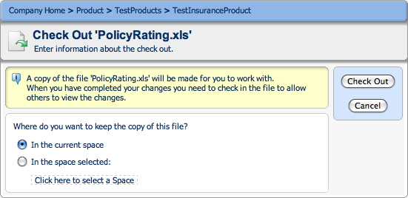
Select “In the current space” and click “Check Out”.
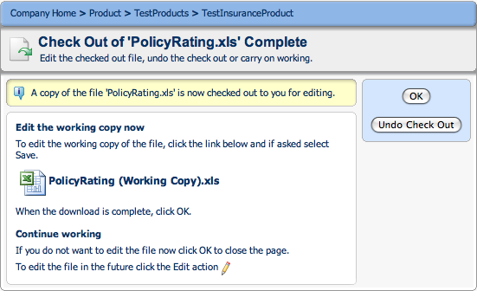
Click on the file and save. When the download is complete click “OK”.
Open the locally saved version of the spreadsheet. Next the new quote information field details need to be incorporated into the assessment rules. Firstly add the field reference details:
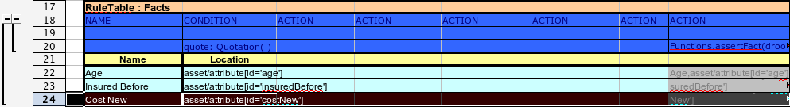
Here a row has been added into the “Facts” rule table. The row contains the following details:
Name - name given to the fact, in this case “Cost New”.
Location – location of field in the quotation model (defined in Quotation.xml), in this case “asset/attribute[id='costNew']”.
Action – Action to perform, in this case “Cost New,asset/attribute[id='costNew']”.

Next we need to add the rules for the new field. In this example the following rule table is added to the end of the spreadsheet (it may be simpler to copy an existing rule table and edit it):
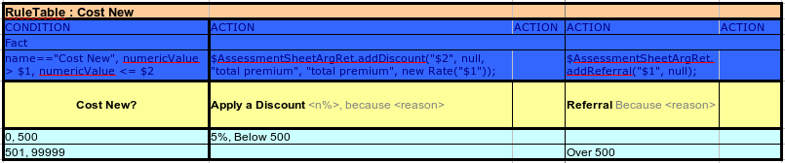
This table looks at the “Cost New” field (defined previously in the Facts rule table on the spreadsheet). Values entered into the “Cost New” between 0 and 500 allow a 5% discount to be applied to the premium. Values between 501 and 99999 are not rateable and get referred back to the underwriter.

Next the spreadsheet and the changes made to it need to be checked into the product space. Select the green arrow below the “PolicyRating (Working Copy).xls”.
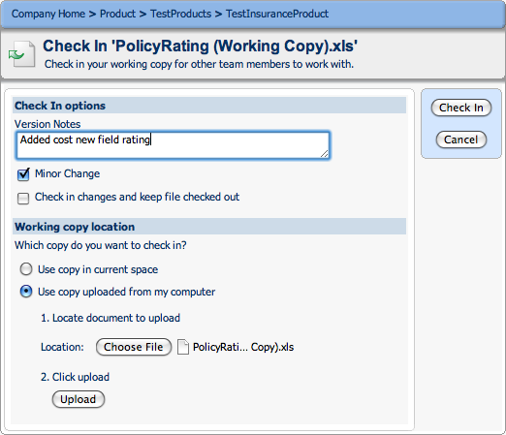
Select “Use copy uploaded from my computer” and select the copy of the file downloaded to your computer. Next click “Upload” and then “Check In”. The changes will now be applied to the original spreadsheet.
Step 4– Make changes available for testing
Once all changes are made click the “Clear configuration cache” in the “Configuration Portlet” to reload the product configurations.
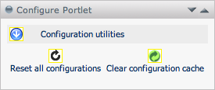
Step 5 – Testing the changes
Test the changes to the product by going to the Sandpit. Here you can select and run the amended product, testing that the changes made are working correctly.
